WISA NEWSLETTER
April 2018

A MESSAGE FROM THE WiSA CHAIR
TO WISA MEMBERS AND THE COSECSA FAMILY

Dear WiSA members, COSECSA Family and Friends,
I trust that you have had an inspiring beginning of 2018 and are excited at what this year has to offer. I’m privileged and honored to be elected the second president of WiSA, a role that I take very seriously and together with the board members we look forward to greater things for the female surgeons and trainees within the COSECSA member countries and hope to be an inspiration to many other females across the globe.
I have three main goals for WiSA for the next 2 years that I would like to summarize as the three C’s: To Capture, to Cultivate and to Commit to excellence.
Capture and celebrate the essence of a female surgeon.
Women have been created and blessed with many unique and beautiful attributes that make us nurturing, dependable, approachable and empathetic and yet fiercely attentive, innovative, strong and enduring. But we also have to balance out other roles- a leader at the work place, a mother, a wife and a friend and mentor and with these come an equally unique set of challenges. I would like to see women surgeons celebrated in these roles and thrive not because of the challenges we face but in spite of them.
Cultivate an inspiring woman surgeon and leader.
WiSA is a platform to cultivate the best we can be not just to survive, but to thrive and excel, take us into to greater heights as women surgeons in this continent.
It is my desire that we will expand and solidify collaboration with support groups e.g. COSECSA, RCSI, COOL and help make further specialized surgical training and education available to many.
There is so much to unearth in our continent, we need to be at the fore front of cutting edge research through collaboration with existing active groups in training for and support of research.
We also want to raise an all rounded and grounded surgeon through Intensification of our mentorship programs in leadership and career growth.
Challenge to Commitment.
We are young as WiSA and the road ahead may seem dreary, perhaps even impossible and to some it may be easier just to settle for less. But I challenge us to dare to dream big.
We have inspiring examples in many great women, who have been trailblazers in unbeaten paths. We have the unwavering support of many mentors and strong male surgeons cheering us on.
I pledge that with the same dedication and attention I have placed in my life and career, I desire to and will take us and WiSA to the next great level so that we too can leave a lasting legacy and be an inspiration to many. We have an opportunity to build a better Africa for Africa, this is our moment, together let’s seize it!
Thank you.

Please continue to support us by constantly logging onto our website: www.womeninsurgeryafrica.org, and following us on Twitter at @WomenSurgAfr and on Facebook
Ms Agneta Odera
WiSA President

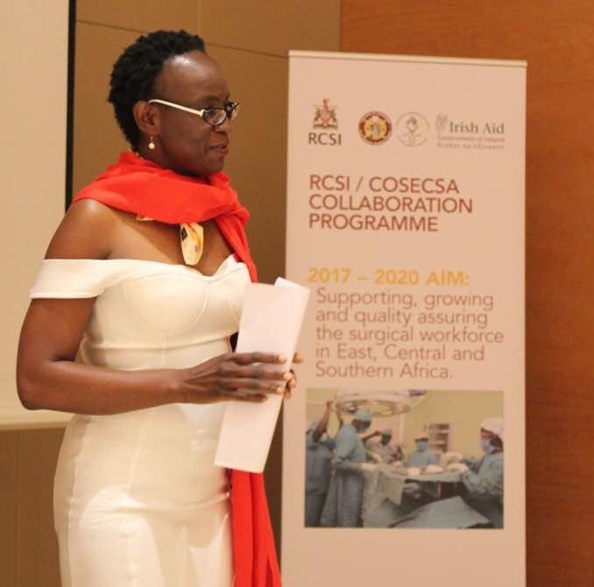
3rd Annual WISA Event in Maputo, Mozambique
7 December 2017
The 7th of December 2017 in Maputo, Mozambique, saw the 3rd Women in Surgery Africa (WiSA) cocktail event at the Gloria Hotel. This event was organized by WiSA Board members and supported by the Royal College of Surgeons of Ireland (RCSI). The event was attended by fellows and members of the College of Surgeons of East, Central and Southern Africa (COSECSA) along with international supporters and stakeholders, such as the Association of Women Surgeons (AWS) from the US.

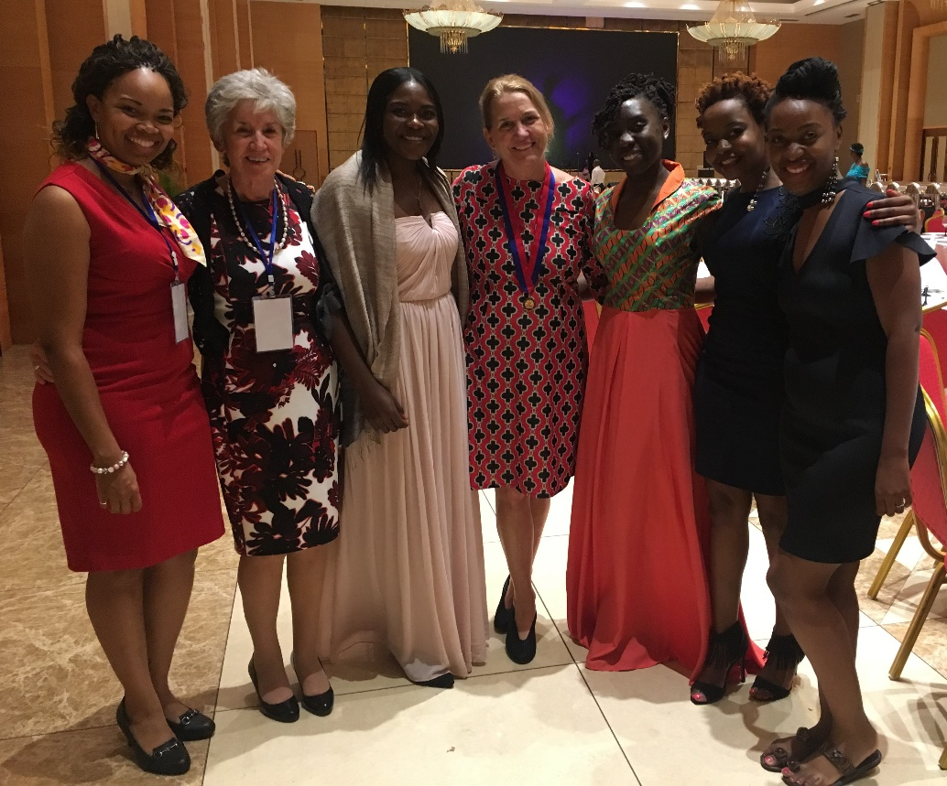

Ms Faith Muchemwa, outgoing WiSA Chair, and Mr Pankaj Jani, COSECSA President, welcomed the crowd to the third annual WiSA event under the theme, “A Mother, Wife, Surgeon and Friend: Keeping the Balance as Today’s Female Surgeon.”

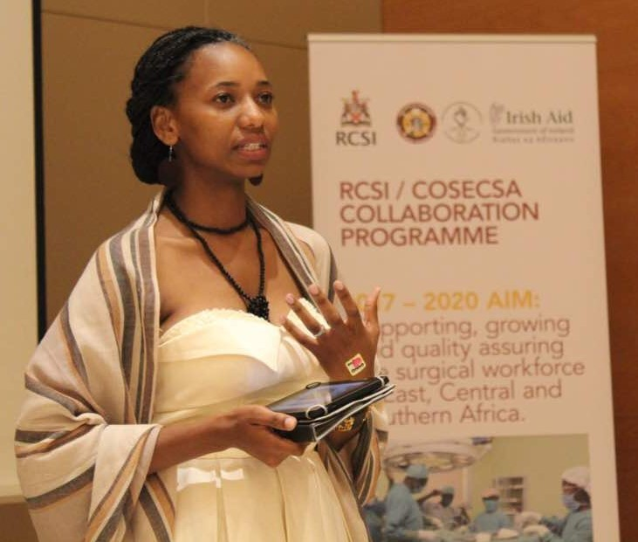
This winning theme, chosen from multiple wonderful entries from our members, was submitted by Josephine Kusano from Zimbabwe. Unfortunately, Josephine could not attend but she shared the inspiration behind the theme: “Why this theme? As a young aspiring female surgeon, I have often been fascinated by how we female surgeons go home afer a long day of work and countless hours in theatre and then transition nicely into being caring mothers, wives, and daughters while finding time for a social life with friends. This is mostly a reflection of my life and the life of my female colleagues around me. The theme came to mind the morning after a weekend 48 hr call. I had a list of emergencies piled up but I had also promised to meet my friends for a night out. This made me suggest this theme because I wondered if most female surgeons felt the same way I did. What does this theme mean to me? This theme does not only reflect my inner thoughts, but as I watch other female surgeons who are excelling in the field of surgery, it motivates me to strive for what I want while keeping a balance.”

Ms Muchemwa surprised the audience by presenting the creation of a new travel award grant in her name. The Faith Muchemwa Legacy Travel grant will be awarded annually to the WiSA AGM theme winner. This new grant will be used to support travel and accommodation expenses for up to 2 nights so that the winner may attend the annual WiSA event.

Dr. Barbara Bass - Keynote Speaker
The Keynote Address was given by Dr Barbara Bass, the John F. and Carolyn Bookout Presidential Distinguished Chair of the Houston Methodist Hospital Department of Surgery and current President of the American College of Surgeons (ACS). Dr Bass’s powerful talk was filled with insight into her experiences as a woman surgeon.

Also in attendance at the event were our honoured visiting guests: COSECSA CEO Rosemary Mugwe, incoming COSECSA president Prof. Jani, Dr. Hilary Sanfey, WiSA patron Dr. Faulal, Eric O’Flynn and Deirdre Mangaoang from RCSI, and Prof. Christopher Lavy from the COSECSA Oxford Orthopaedic Link (COOL), a collaboration between the Oxford University and COSECSA. Dr. Sanfey, Deirdre Mangaoang and Prof Lavy each presented an award for a WiSA Travel Grantee.
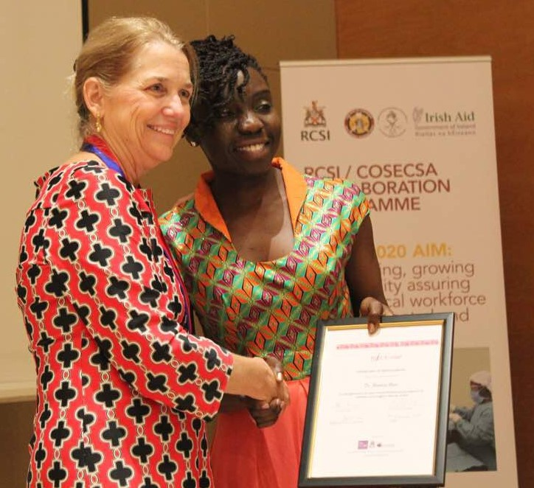

Meet the WISA Travel Grant Winners
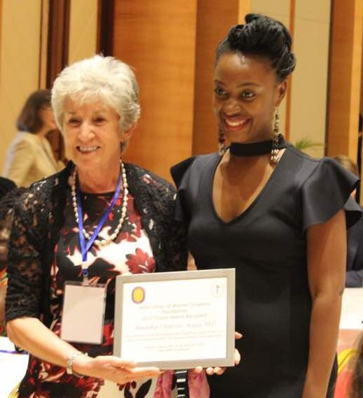
Three WiSA members were recipients of travel grants which were awarded by RCSI, COOL and AWS; Dr Mumba Chalwe from Zambia (AWS grantee), Dr Patricia Shinodo from Zambia (COOLS/Oxford grantee), and Dr Precious Mutambanangwe from Zimbabwe (RCSI grantee).

Mumba Chalwe (Zambia) – AWS Travel Grant

The AWS Travel Grant was presented to Dr. Mumba Chalwe, who specializes in Urology, by Dr. Hilary Sanfey. Dr. Chalwe described her experience, “The AWS travel grant provided me with the opportunity to meet some of the most amazing surgeons from within the region and beyond. One of my most memorable trips!”

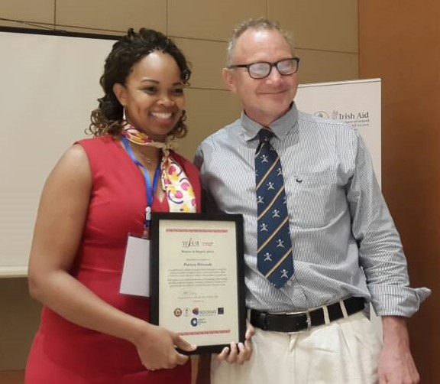
Patricia Shinodo (Zambia) – COOLS/Oxford Travel Grant

The COOLS Travel Award was presented to Dr. Patricia Shinodo by Prof Chris Lavy. To Dr. Shinodo, “Winning the WiSA travel award helped strengthen my resolve to perfect my surgical knowledge and skill. It gave me the opportunity to be surrounded by great female ‘surgical powerhouses,’ to learn from and network with peers, and seniors alike. I will always be grateful.”

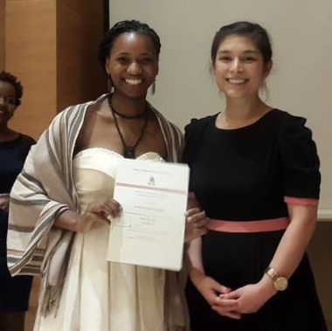

Precious Mutambanangwe (Zimbabwe) – RCSI Travel Grant

The RCSI Travel Award was presented to Dr. Precious Mutambanangwe by Deirdre Mangaoang of RCSI.

Congratulations to our three winners, you have made your countries very proud!
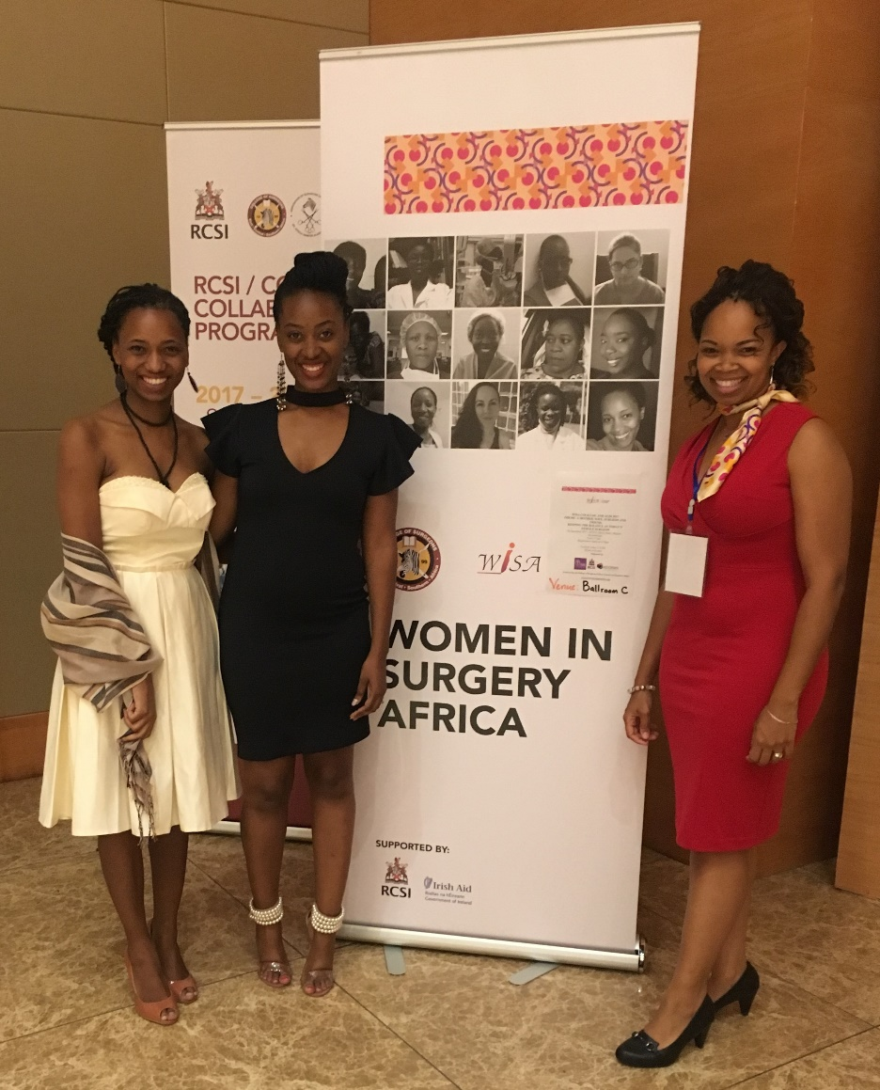

WiSA Membership Report
April 2018
WiSA Membership has been slowly increasing since its inception. In 2015 our first year, 100 people attended the WiSA launch in Blantyre, Malawi. At that time, 30 attendees registered as members of WiSA. In 2016 our second year, we had 55 attendees at our dinner event in Mombasa, Kenya and our membership numbers increased to 47. Currrently there are 59 registered WiSA members. On the WiSA WhatsApp group, which is open to all women surgeons and those still in training, we now have 106 participants up from 56 in December 2017. We are still looking for our first participant from Namibia!
We have noted a significant increase in participation in WISA activities e.g. suggesting themes for the AGM, travel grant applications and meetings with country chapters. Whilst there were only 3 applicants for the travel grants in 2016, we have had 15 applicants in 2017.
We currently have country representatives in 6 countries: Dr Violet Lupondo from Tanzania, Dr Florence Umurangwa from Rwanda, Dr Mumba Chalwe from Zambia, Precious Mtambanengwe from Zimbabwe, Shelmith Muthee from Kenya and Linda Chokotho from Malawi. It is our goal to have WiSA country representatives in all COSECSA Countries in order to establish a strong and active WISA country chapter representation within each member country. If you are interested in being a representative from Mozambique, Uganda, Namibia, South Sudan, Ethiopia and Burundi please contact us.
WISA is becoming more visible even within those countries where there are few COSECSA fellows. We hope that this will make female surgeons/surgeons in training more visible within their countries, encourage participation at WISA and COSECSA events and encourage students/ medical doctors to become surgeons.
Future Membership Plans include creating a database of all women surgeons and those in training and identify them by the country where they are practicing and their areas of specialties. We hope with this information to reach out to potential WISA members. We also look forward to developing relationships with WiSA non COSECSA members e.g. MMED Surgical graduates and also with the surgical societies of individual countries. Finally, this year we hope to encourage collaborative research work within the region amongst our members.

Renewal of subscription fees
We kindly remind members of renewal payment of subscription fees. It has been noted that our members easily pay their annual fees when they attend the AGM meeting. Currently our website is up and running and payment options online via Paypal are available. Please note that only active and paid up members of WiSA will enjoy the benefits attached which include being able to participate for the grants and scholarships available.

WiSA Mentorship Programme Report
April 2018
In 2017, a 6 month pilot mentorship program was run, 13 pairs of mentors / mentees were assigned. Each paired up member was sent an introductory email to the program with instructions to submit a signed-up contract for 6-month mentorship program, during which they would make 6 weekly contacts via an agreed upon medium of communication, whether by Skype, email or WhatsApp. A minimum of 4 sessions during the 6-month period was expected.
Mentorship resources and guides generously donated by RCSI were made available through the COSECSA School for Surgeons’ website and access to this portal was made available through an individual’s log in for the WISA Mentorship portal on https://www.schoolforsurgeons.net/enrol/index.php?id=95. This part of School for Surgeons is limited to mentorship program participants and was not available to the wider group of COSECSA trainees.
An online exit survey was administered in February 2018 with the following results:
Most of them made only one contact via email and then never set up subsequent sessions.
The most commonly cited limiting factor was lack of time/ being too busy.
Another problem listed was issues with the log in access to the SFS mentorship portal.
All those who participated stated interest in maintaining the mentorship program and wished to be re-assigned to different mentors with the aim of trying to improve participation.

Recommendations to reinforce and improve the mentorship program 2018 and beyond:
WiSA recognizes that mentorship is one of its core activities and wants to be heavily vested in ensuring that this program succeeds.
We as the WiSA board together both COSECSA/ RCSI recommend that we re- run the 6-month pilot program in 2018 with specific goals in mind to improve participation.
An online entry survey into the program with expectations will be sent out in May 2018. Those who re- affirm their interest and commitment will then be enrolled into the 2018 six-month program starting June- November 2018.
All participants will receive via email specific instructions on:

1. WiSA Mentorship program contract agreement form- this is to be signed by both the mentor and mentee and sent back to the mentorship program coordinator
2. What the WiSA mentorship program is.
3. WiSA First mentoring meeting Agenda
4. A working log in access to the mentorship portal on School for Surgeons with online learning resources and videos on mentorship.
5. How to install WhatsApp and Skype for communication.
6. An attachment of the WiSA Pocket Mentor guide for reference during their discussions.
7. Monthly contact from the Program coordinator to the pairs to ensure they are in constant communication.

An exit survey will then be administered at the end of November 2018 and a report will be presented at the WiSA /AGM 2018 Dec meeting. During this session, a few mentors / mentees present will share their experiences and a small presentation will also be made on the importance and benefits of mentorship and then launch wider participation for the WiSA members. We hope that this will help grow the mentorship program and help in building a brilliant and all rounded surgeon and that we can set an excellent model for other training programs to adapt.

WiSA Research Initiative
April 2018
WiSA has a special interest in fostering general surgical research (all specialties) and surgical education research. We are currently brainstorming ways in which to develop quality research initiatives amongst women surgeons in the COSECSA region starting in 2018. In collaboration with Dr. Hilary Sanfey, from the Association of Women Surgeons, we are delighted to begin providing free research resources for all those who are interested. Our first offering is a powerpoint presentation and introduction on how to engage in good surgical education research by Dr. Hilary Sanfey. Please visit our website to access and download this great resource. In addition, WiSA welcomes input and ideas from all our members regarding this research initiative so please share with us your comments and ideas via email or WhatsApp.

